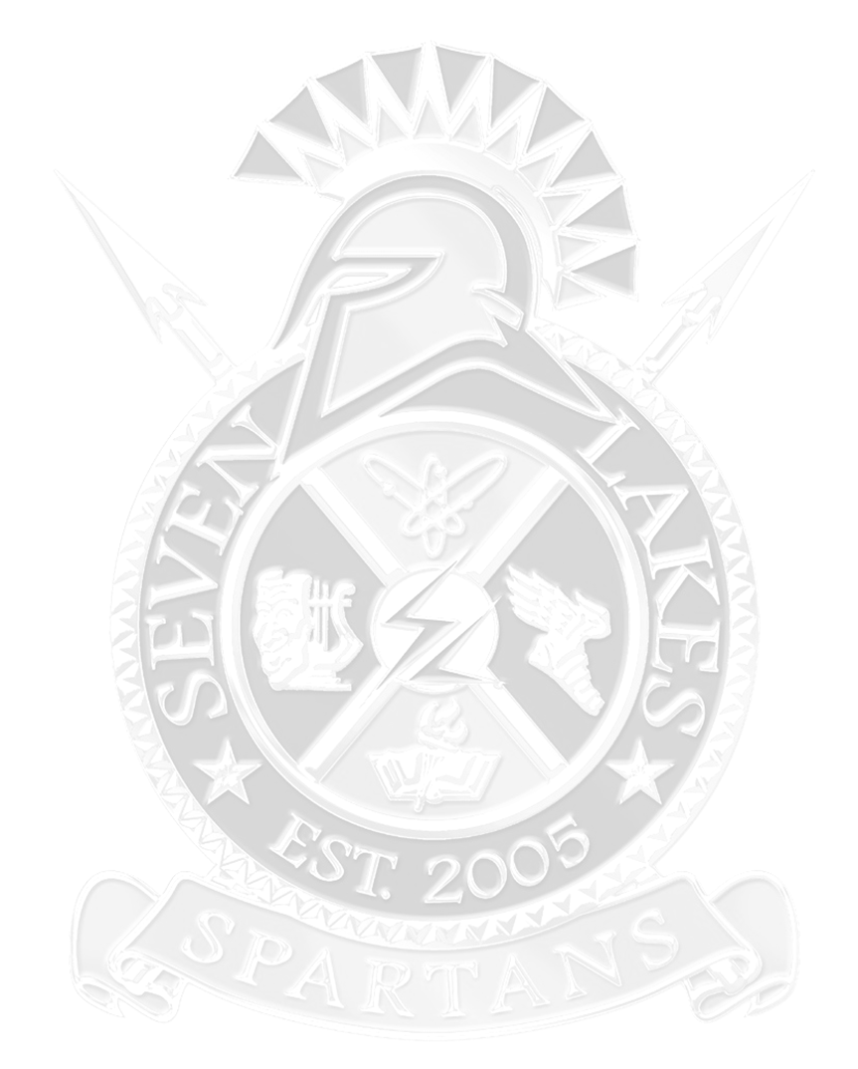2018 SEVEN LAKES SHOWCASE CROSS COUNTY INVITATIONAL
Featuring The Gary Derks Memorial Boys and Girls 5K (Varsity)

Hosted by Seven Lakes High School
Coaches,
Thank you for attending our Seven Lakes Showcase. We will do our best to make sure your teams have a great experience here at Seven Lakes High School. If you have any questions or concerns, please contact me at scottakenney@katyisd.org or my cell number 281-658-3835. We are looking forward to our best showcase ever! Coach Scott Kenney

DATE
Saturday, September 1st, 2018

- LOCATION
Seven Lakes High School
9251 South Fry Road
Katy, TX 77494

- TIME SCHEDULE
7:00 a.m. Coaches Meeting at the east room of the concession stand
7:20 a.m. Boys Varsity Gary Derks Memorial 5k- limit 10-scoring 7 runners-chip timed
7:45 a.m. Girls Varsity Gary Derks Memorial 5k- limit 10-scoring 7 runners-chip timed
8:10 a.m. Jr. Varsity Boys 5k- limit 10-scoring 7 runners –chip timed
8:35 a.m. Jr. Varsity Girls 3200m- limit 10-scoring 7 runners-chip timed
8:50 a.m. Freshmen Boys 3200m- limit 10-scoring 7 runners-chip timed
9:05 a.m. Open Division 3200-unlimited-open to boys & girls-not timed
. * Awards Ceremony-Immediately following the Open Division 3200m- Top ten individuals and top teams will be recognized

- DIVISION
Girls: Varsity 5k, Junior Varsity 3200m, Open Division 3200
Boys: Varsity 5k, Junior Varsity 5K, freshmen 3200m, Open Division 3200

- AWARDS
Varsity: Team championship and Team Runner-Up Plaques
Medals: Top twenty (20) individuals
Medals: Seven (7) to the first place team

JV/Freshman: Team championship and Team Runner-Up Plaques
Medals: Top twenty (20) individuals
Medals: Seven (7) to the first place team
The Awards ceremony will be held at the completion on the meet.
Plenty of high-fives and cheering

VII. COST: Boys’ Teams…$75; Girls’ Teams… $75; (Maximum fee of $150 per school); The KISD athletic agreement is in effect for this athletic event.
IMPORTANT: Please make checks payable to SLHS Boys’ Cross Country Attention Scott Kenney
IMPORTANT!
If you send checks via mail, please address them to: Seven Lakes High School, c/o Boys’ XC- Scott Kenney; 9251 South Fry Rd. Katy, TX 77494.*Refund Policy: Please understand that we cannot control the weather, and any meet fees will not be refunded if cancellation is deemed necessary for the safety of our athletes.

VIII. ROSTERS: An excel spreadsheet will be sent out the last week of August. Please follow the directions and coding on the excel spread sheet. Rosters of all possible contestants must be submitted via email to: scottakenney@katyisd.org The deadline for rosters is Monday, August 27, 2018. Please include the names of all possible runners; (last name, first name), Division number, Gender, and Team Number. You will not be able to add individuals to your roster after the due date. We are taking entries and scoring the Varsity Boys, Varsity Girls, Junior Varsity Boys, Junior Varsity Girls, and Freshmen Boys Divisions.

IX. REMIND: Please sign up with the Remind APP. The Seven Lakes Showcase Code is @7lakesxc

X. SPECTATOR ADMISSION: Spectators will be charged an entrance fee. Adults: $5 and Students: $3

XI. CONCESSIONS: A concession stand will be open and serving a variety of snacks and drinks including nachos, chips, candy, and various drinks. Pre-ordered school meals are available upon request.

XII. OFFICIAL MEET APPARAL PROVIDER: Fine Design Graphics

If you have any questions or concerns, please do not hesitate to contact us.
Scott Kenney
Seven Lakes High School Boys Cross Country
9251 South Fry Road
Katy, TX 77494
School phone 281-237-2896 School FAX 281-644-1785
scottakenney@katyisd.org cell phone 281-658-3835
Remind Code: @7lakesxc

Top 10 Varsity Boys 5k Time | Top 10 Varsity Girls 5K Time
1.Theo Goff Oak Ridge High School 15:12.90 2016 | 1. Sandy Raines Kingwood High School 17:56.2 2012
2. Devin Fahey Stratford High School 15:28.78 2016 | 2. Reagn Kappel Cinco Ranch High School 18:12.56 2016
3. Austin Richard Stratford High School 15:34.5 2014 | 3. Brittany Innis Cedar Park High School 18:28.4 2012
4. Dillon Worley Klein High School 15:38 2011 | 4. Alyssa Balandran Tompkins High School 18:28.81
5. Daniel Figueroa Tompkins High School15:39.00 2016 | 5. Erica Brown Seven Lakes High School 18:32.61 2013
6. Alec Esposito Cy-Woods High School 15:47.43 2016 | 6. Reagan Kappel Cinco Ranch High School 18:35.2 2015
7. Roderick Bell Seven Lakes High School 15:48.3 2014 | 7. Jessica Hergott Kingwood High School 18:36.87 2016
8. Andrew Gandy Seven Lakes High School 15:49.86 2016 | 8. Jessica Ellis Westlake High School 18:37.08 2013
9. Alex LeRoux Seven Lakes High School 15:51 2010 | 9. Lina Spjut Cy-Woods High School 18:39.18 2016
10. Nathan Gift Cinco Ranch High School 15:51.3 2015 | 10. Lauren Fritz Cy-Fair High School 18:41 2011
Top 10 JV Boys 5k Times | Top 10 JV Girls 2 mile Times
1. Andrew Koob Seven Lakes High School 17:01.34 2016 | 1. Kassandra Luna Cy-Fair High School 12:10 2011
2. Erick Torres Cypress Ranch High School 17:18.98 2016 | 2. Allison Tracy Seven Lakes High School 12:15 2011
3. Leonel Perez Cedar Park High School 17:24.38 2012 | 3 Caroline Wheat Kingwood High School 12:18.50 2016
4. James Yeargan Seven Lakes High School 17:24.4 2014 | 4. Amber Byrd Cy-Woods High School 12:26.43 2016
5. Anthony Mata Cedar Park High School 17:24.58 2012 | 5. Lauren Roberts Katy High School 12:27 2011
6. David Church Cedar Park High School 17:24.84 2012 | 6. Dalia Najjar Cinco Ranch High School 12:28.67 2016
7. Eric Nakazono Tompkins High School 17:26.27 2016 | 7. Tori Welkener Seven Lakes High School 12:31.18 2013
8. Gabriel Garibaldi Seven Lakes High School 17:26.37 2016 | 8. Allie Self Kingwood High School 12:31.71 2016
9. Paul Parra Morton Ranch High School 17:30.17 2016 | 9. Elizabeth Davis Cypress Woods 12:34.30 2016
10. Junior Salazar Morton Ranch High School 17:30.56 2012 | 10. Sofia Rubio 9 Katy Tompkins 12:34.78 2016
Top 10 Freshmen Boys 2 Mile Times
1.Carson Slater Seven Lakes High School 10:14.80 2016
2. Francis Galdino Stratford High School 10:27.60 2016
3. Brian Gonzalez Katy High School 10:41 2011
4. Samuel Flusche Cinco Ranch 10:47.91 2016
5. Peyton Hanna Seven Lakes High School 10:50.30 2016
6. Andrew Nugent Seven Lakes High School 10:50.50 2016
7. Andrew Koob Seven Lakes High School 10:51.1 2014
8. Riley Burnside Mayde Creek High School 10:55 2011
9. Robbie Cook-Adams Cy-Woods High School 10:55.25 2016
10. Chris Landin Brazoswood High School 10:56 2011

