**2019 SBISD INVITATIONAL COURSE MAP 5K**

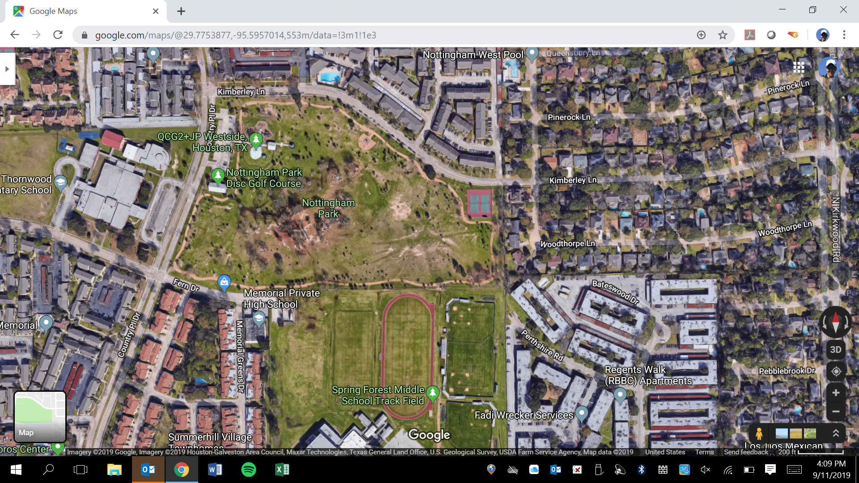

2 mile

3 mile

1 mile

Medical

Area

Restrooms

Camp

Area

FINISH

Restrooms

START

BUS PARKING ALONG PERIMTER OF PARK

BOX ASSIGNMENTS

1.

2.

3.

4.

5.

6.

7.

8.

9.

10.

11.

12.

13.

LEGEND

1st Loop Yellow

2nd Loop Red

3rd Loop Blue